**Bahria University Karachi Campus**

# Department of Software Engineering

# ASSIGNMENT # 02 – Fall 2020

|  |  |  |
| --- | --- | --- |
| Course Title: **Computing Fundamentals** |  | Course Code: **CSC-110** |
| Class: **BSE – 1(A/B)** |  | Shift: **Morning** |
| Course Instructor: **Dr. Salahuddin** |  | Max. Marks: **7.0** |
| Date: **25th Dec 2020** |  | Due Date: **3rd Jan 2021** |

|  |  |  |  |  |  |  |  |  |  |  |  |  |  |
| --- | --- | --- | --- | --- | --- | --- | --- | --- | --- | --- | --- | --- | --- |
| Student’ Name: _M MUAZ SHAHZAD  Registration #: 02-131202-081 | |  |  |  | | --- | --- | --- | | **Q#** | **Marks Assigned** | **Marks Obtained** | | **1** | **4** |  | | **2** | **3** |  | | **Total** | |  | |

**Note:** (i) Please submit your assignment via BU-LMS in MS-Word document only.

(ii) Submit assignment before due date. After due date, LMS system will not accept your submission.

**[CLO 3]**

**Q1.** Write the **algorithm**, draw the **flowchart**, and write **pseudo code** for the following:

**[Marks 4]**

1. To find the sum of all even numbers till 100.  
     
   **Algorithm:  
     
   STEP 1:** START **STEP 2:** Print “Sum of All Even Num till 100” **STEP 3:** Initialize Sum = 0; **STEP 4:** Using for Loop

**STEP 5:** Initialize and give Condition then increment in loop **STEP 6:** If the Reminder is 0 Than Go to next step (n % 2 = 0)

**STEP 7:** Calculate Sum (sum = sum + n)

**STEP 8:** Print Sum **STEP 9:** Stop

**Flow Chart:** 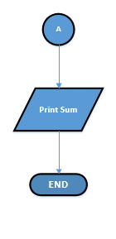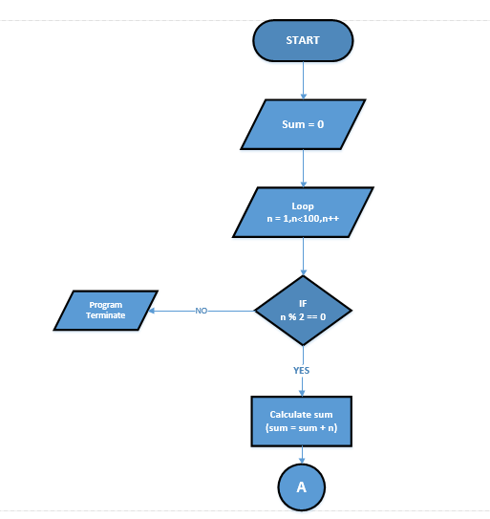

**pseudo code:**  
1: Initialize sum to zero  
2: For Loop (initialize n to one, n less than 100, Increment n)

3: if (n modulus 2 equal to 0)

4: Add n in sum and store in sum

5: Print sum  
6: Stop  
  
**(b) To find the sum of all odd numbers till 100**.  
 **Algorithm:  
  
STEP 1:** START **STEP 2:** Print “Sum of All Even Num till 100” **STEP 3:** Initialize Sum = 0; **STEP 4:** Using for Loop

**[Marks 3]**

**STEP 5:** Initialize and give Condition then increment in loop **STEP 6:** If the Reminder is not 0 Than Go to next step (n % 2 = 0)

**STEP 7:** Calculate Sum (sum = sum + n)

**STEP 8:** Print Sum **STEP 9:** Stop **FLOW CHART:**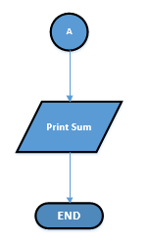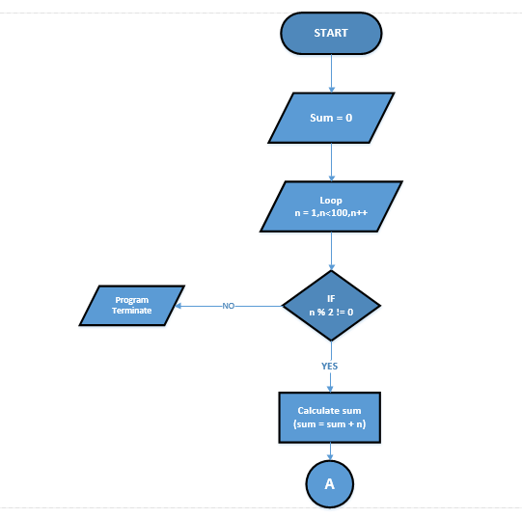

**pseudo code:**  
1: Initialize sum to zero  
2: For Loop (initialize n to one, n less than 100, Increment n)

3: if (n modulus 2 not equal to 0)

4: Add n in sum and store in sum

5: Print sum  
6: Stop

**Q2**. Write the HTML code for the below table. Paste your HTML code and Snapshot of your output. **Your name** and **Enrollment number** should appear above the table.

|  |  |  |  |  |  |
| --- | --- | --- | --- | --- | --- |
| **Subject Name** | **Marks Obtained** | | | **Grade** | **Result** |
| Theory | Practical | Total |
| *English* | 78 | - |  | B | Pass |
| *Math* | 85 | 82 | 167 | A | Pass |
| *Computer* | 71 | 69 | 140 | B- | Held* |
| * Result withheld. | | | | | |

**CODE:**<!DOCTYPE html>

<html>

<head>

<title>Blnak</title>

</head>

<body style="background-color: lightyellow;">

<tr>

<td style="font-family: calibri;text-align: left;"><b>NAME:</td><td style="text-align:left;">M MUAZ SHAHZAD</b></td></tr>

<br><tr><td style="font-family: calibri;text-align: left;"><b>ENROLLMENT NO:</td><td style="text-align:left;">02-131202-081</td></tr><br><br><br>

</body>

<table style="width: 44%;" border="5"; cellspacing="0">

<tbody;>

<tr style="background-color: green;">

<td rowspan="2">Subject</td>

<td style="text-align: center;" colspan="3">Marks Obtianed</td>

<td style="text-align: center;" rowspan="2">Grade</td>

<td style="text-align: center;" rowspan="2">Result</td>

</tr>

<tr style="background-color: green;">

<td>Theory</td>

<td>Practical</td>

<td>Table</td>

</tr>

<tr>

<td style="font-style: italic;">English</td>

<td>78</td>

<td>-</td>

<td>&nbsp;</td>

<td>B</td>

<td>Pass</td>

</tr>

<tr>

<td style="font-style: italic;">Math</td>

<td>85</td>

<td>82</td>

<td>167</td>

<td>A</td>

<td>Pass</td>

</tr>

<tr>

<td style="font-style: italic;">Computer</td>

<td>71</td>

<td>69</td>

<td>140</td>

<td>B-</td>

<td>Held*</td>

</tr>

<tr>

<td colspan="8">*Result Withheld.</td>

</tr>

</tbody>

</table>

<!-- DivTable.com -->

</body>

</html>  
  
  
**Output:**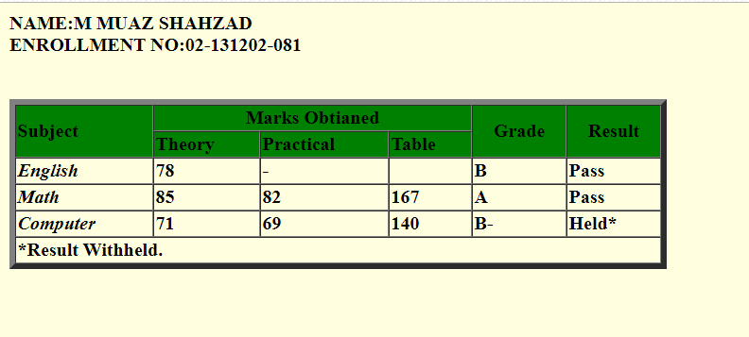

_________________________________-End-_______________________________